TIPS-Transitions 4 – Ready. Set, Go

Name: __________________________ Class: ___________ Date: _______________

ON TO HIGH SCHOOL

Dear Parent or Family Partner,
We are learning about how high school is different from the middle grades and how to plan for success in grade 9. I hope you enjoy this activity with me. This assignment is due _____________________________

Sincerely,
______________________________________
Student Signature

FAMILY DISCUSSION—GO for the GOAL!

Many things are different in high school from the middle grades. With some good ideas and clear plans, you will be ready to succeed in high school.

Talk with a family partner about your goals in high school. Who is working with you? _____________________

For each goal listed below, YOU write one idea of your own. Read your statement to your family partner.

Ask your family partner for one idea of how he/she will help you reach that goal. YOU write that response.

In high school, attendance is very important. If you miss class time,

you will miss a lesson and it is hard to “catch up.” What is your plan for regular, on-time attendance?

My idea:

________________________________________________________________________________________

ASK your family partner: How will you help me meet my goal for good attendance in grade 9?

________________________________________________________________________________________
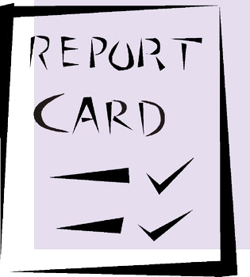

In high school, passing your courses is very important. If you fail a course, you will not have the credits you need to graduate from high school on time and with your friends. You will be more likely to pass if you attend class every day,

do your homework, and study for tests. What is your plan to pass your courses?

My idea:

________________________________________________________________________________________

ASK your family partner: How will you help me meet my goal to pass my courses in grade 9?

________________________________________________________________________________________

In high school, it is fun to participate in activities that interest you—

sports, music, art, drama, community service, or other clubs.

You will meet new friends, build your talents, and have some great experiences.

What is your plan for participating in extra-curricular activities?

My idea:
________________________________________________________________________________________

ASK your family partner: How will you help me meet my goal to participate in activities that interest me??

________________________________________________________________________________________

—Continue on the back page.—

PREDICT THE FUTURE

Next year is the start of something big. You will be a freshman in grade 9. Then, you will move on to grades 10, 11, and 12 and will graduate from high school. The path to graduation starts in grade 9 with a plan for success.

Take a look into the future.

What do you want to accomplish in Grade 9?

In grade 9, I predict that I will accomplish the following: __________________________________________

________________________________________________________________________________________

________________________________________________________________________________________

Read your prediction to your family partner.
ASK: Look into the future. How will you help me succeed in grade 9?

________________________________________________________________________________________

Why do you want to graduate from high school on time?

I predict that I will graduate from high school on time because I want to ______________________________

________________________________________________________________________________________

________________________________________________________________________________________

Read your prediction to your family partner.
ASK: Look into the future. How will you help me graduate from high school on time?

________________________________________________________________________________________

HOME-TO-SCHOOL COMMUNICATION
Dear Parent or Family Partner,

Please give your reactions to this activity. Write YES or NO for each statement.

1. ______ My teen understood the homework and was able to discuss it.
2. ______ My teen and I enjoyed the activity.
3. ______ This assignment helped me think about how I can help my student succeed in grade 9 and beyond.
Comment: ________________________________________________________________________________
Parent Signature: ________________________________________________________________________

© Epstein, J. & Mac Iver, D. 2016. Teachers Involve Parents in Schoolwork (TIPS). Seattle Transitions Project. Baltimore: Johns Hopkins University.

